**Codework Digital**

**Team members:**

Chanse Stephens

Cat Schnelle

Elijah Pemberton

Kevin Sims

**Group # 4**

**Course:** CSCI441-VA

**Github**: <https://github.com/CSchnelle/Codework-Digital>

theTalkMadeSimple.com

April, 29th 2020

# 

# Product Overview

TheTalkMadeSimple.com is a desktop and mobile electronic course website. This project is designed to create a basic template shell for our client to easily upload media content for users. This webpage will host a curriculum created by our client in order to support parental discourse with their children for important life topics.

## Features

The website includes a landing page with several “call to action” sections, a Get Started page that displays a trailer, site information and additional call to action sections, a Lessons page where users can see their lesson planes one first going to the secure sales page where users can pay for premium content, an account creation and login feature that will only capture email addresses and allow users to purchase premium content and give their accounts access. This site also includes visitor tracking using Google Analytics.

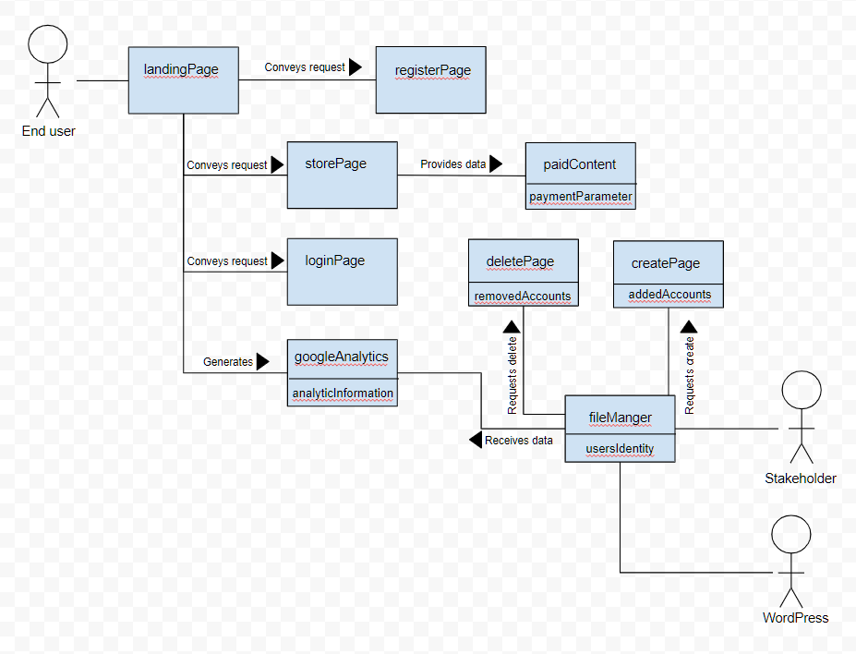

### System Diagram

This diagram shows the basic site features and their relationships.

## Design

Using a purposeful layout with a simple interface that is easy to navigate, TheTalkMadeSimple is a responsive template that will keep users engaged.

# How to

This website will be hosted by WordPress and will be accessible via a browser on any desktop or mobile devices with internet access.